LINCOLN ROWING CENTRE
SOLO SINGLE SCULLING POLICY
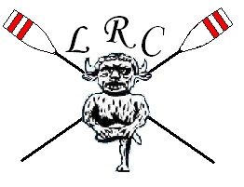
Solo single sculling occurs when an individual rows a single scull on the river with no other person at the boathouse or on the river. The reduction in safety backup increases the risk to the individual.
In order to be eligible to solo single scull at Lincoln Rowing Centre, the sculler must comply with the following requirements.
Membership
The sculler shall:
- Complete the current Online Membership Form.
- Be a member of British Rowing.
- Be up to date on subscription payments.
Competence
The sculler shall be certified as competent to solo single scull by the Lincoln Rowing Centre Captain.
Safety
The sculler shall:
- Accept the increased risk.
- Carry a mobile phone.
- Be over 18.
- Assess the water and weather conditions in accordance with the advice and guidance in RowSafe.
- Check the boat and heel restraints in accordance with the advice and guidance in RowSafe.
- Be aware of the water hazards on the Witham.
- Notify another responsible adult with their intentions, duration of outing and emergency plan prior to boating.
- Notify same adult upon return.
- Sign out and on return using the appropriate book in the small boathouse.

